Spelling Test Date: Friday 22nd March 2024

Alternative List

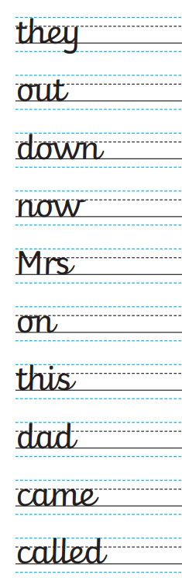

Spelling Test Date: Friday 19th April 2024

Alternative List

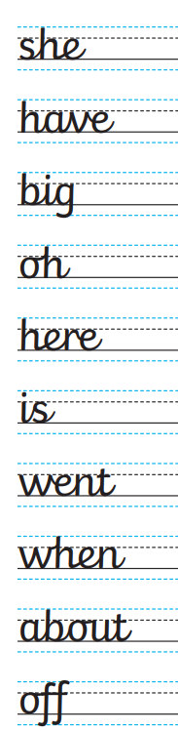

Spelling Test Date: Friday 3rd May 2024

Alternative List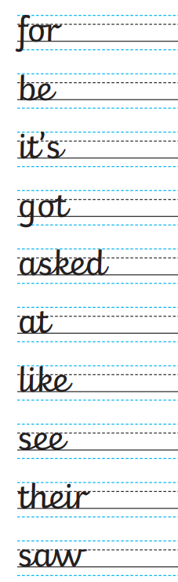

Spelling Test Date: Friday 17th May 2024

Alternative List

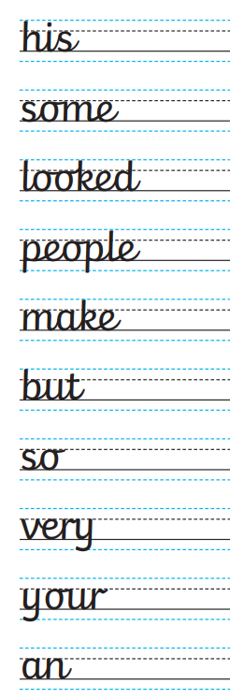

Spelling Test Date: Friday 7th June 2024

Alternative List

